Chapter 16, Problem 53.

In the circuit of Fig. 16.76, the switch has been in position 1 for a long time but moved to position 2 at t = 0. Find:

- v(0⁺), dv(0⁺)/dt
- v(t) for t ≥ 0.

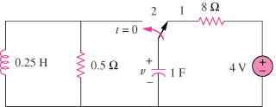

Figure 16.76
For Prob. 16.53.

